

**Mawlana Bhashani Science And Technology University**

**Lab-Report**

Lab Report No: 07

Group member ID: IT-18013 and IT-18028

Date of Performance: 30-06-2021

Date of Submission: 30-06-2021

Name: Fatema-tuj-Jannat

ID: IT-18028

3rd Year 2nd Semester

Session: 2017-2018

Dept. of ICT, MBSTU

**Submitted by Submitted To**

Nazrul Islam

Assistant Professor

Dept. of ICT

MBSTU.

**Socket Programming:**

Socket programming is a way of connecting two nodes on a network to communicate with each other. One socket (node) listens on a particular port at an IP, while other socket reaches out to the other to form a connection. Server forms the listener socket while client reaches out to the server.

**State diagram for server and client model:**

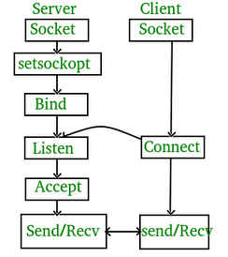

**Stages for server:**

**Socket creation:**



**sockfd:** socket descriptor, an integer (like a file-handle)  
**domain:** integer, communication domain e.g., AF_INET (IPv4 protocol) , AF_INET6 (IPv6 protocol)  
**type:** communication type  
SOCK_STREAM: TCP(reliable, connection oriented)  
SOCK_DGRAM: UDP(unreliable, connectionless)  
**protocol:** Protocol value for Internet Protocol(IP), which is 0. This is the same number which appears on protocol field in the IP header of a packet.

**1.Briefly explain the term IPC in terms of TCP/IP communication.**

**Ans:**

In [computer science](https://en.wikipedia.org/wiki/Computer_science), inter-process communication or interprocess communication (IPC) refers specifically to the mechanisms an [operating system](https://en.wikipedia.org/wiki/Operating_system) provides to allow the [processes](https://en.wikipedia.org/wiki/Process_(computing)) to manage shared data. Typically, applications can use IPC, categorized as [clients and servers](https://en.wikipedia.org/wiki/Client%E2%80%93server_model), where the client requests data and the server responds to client requests. Many applications are both clients and servers, as commonly seen in [distributed computing](https://en.wikipedia.org/wiki/Distributed_computing).

IPC is very important to the design process for microkernels and microkernels, which reduce the number of functionalities provided by the kernel. Those functionalities are then obtained by communicating with servers via IPC, leading to a large increase in communication when compared to a regular monolithic kernel. IPC interfaces generally encompass variable analytic framework structures. These processes ensure compatibility between the multi-vector protocols upon which IPC models rely.

An IPC mechanism is either synchronous or asynchronous. Synchronization primitives may be used to have synchronous behavior with an asynchronous IPC mechanism.

**2. What is the maximum size of a UDP datagram? What are the implications of using a packet-based Protocol as opposed to a stream protocol for transfer of large files?**

**Ans:**

It depends on the underlying protocol i.e., whether you are using IPv4 or IPv6.

* In IPv4, the maximum length of packet size is 65,536. So, for UDP datagram you have maximum data length as:

65,535 bytes - 20 bytes (Size of IP header) = 65, 515 bytes (including 8 bytes UDP header)

* In IPv6, the maximum length of packet size allowed is 64 kb. So, you can have UDP datagram of size greater than that.

NOTE: This size is the theoretical maximum size of UDP Datagram, in practice though, this limit is further constrained by the MTU of data-link layer (which varies for each data-link layer technology, but cannot be less than 576 bytes), considering that, maximum size of UDP datagram can be further calculated as (for IPv4):

* 576 bytes - 20 bytes(IP header) = 556 (including 8 bytes UDP header)

**3) TCP is a reliable transport protocol, briefly explain what techniques are used to provide this reliability.**

**Ans:**

A number of mechanisms help provide the reliability TCP. Each of these is described briefly below:

Duplicate Data Detection: It is possible for packets to be duplicated in packet switched network; therefore TCP keeps track of bytes received in order to discard duplicate copies of data that has already been received.

Retransmissions: In order to guarantee delivery of data, TCP must implement retransmission schemes for data that may be lost or damaged. The use of positive acknowledgements by the receiver to the sender confirms successful reception of data. The lack of positive acknowledgements, coupled with a timeout period calls for a retransmission

Sequencing : In packet switched networks, it is possible for packets to be delivered out of order. It is TCP's job to properly sequence segments it receives so it can deliver the byte stream data to an application in order.

Timers: TCP maintains various static and dynamic timers on data sent. The sending TCP waits for the receiver to reply with an acknowledgement within a bounded length of time. If the timer expires before receiving an acknowledgement, the sender can retransmit the segment.

**4) Why are the htons(), htonl(), ntohs(), ntohl() functions used?**

**Ans:**

**htons():**

The **htons()** function is **used** to convert a short (2-byte) integer from the local host byte order to standard network byte order.

**htonl():**

The **htonl()** function is **used** to convert a long (4-byte) integer from the local host byte order to standard network byte order.

**ntohs():**

The **ntohs()** function is **used** to convert a short (2-byte) integer from the standard network byte order to the local host byte order.

**ntohl():**

The **ntohl()** function is **used** to convert a long (4-byte) integer from the standard network byte order to the local host byte order.

**5) What is the difference between a datagram socket and a stream socket?**

**Ans:**

A stream socket is like a phone call -- one side places the call, the other answers, you say hello to each other (SYN/ACK in TCP), and then you exchange information. Once you are done, you say goodbye (FIN/ACK in TCP). If one side doesn't hear a goodbye, they will usually call the other back since this is an unexpected event; usually the client will reconnect to the server. There is a guarantee that data will not arrive in a different order than you sent it, and there is a reasonable guarantee that data will not be damaged.

A datagram socket is like passing a note in class. Consider the case where you are not directly next to the person you are passing the note to; the note will travel from person to person. It may not reach its destination, and it may be modified by the time it gets there. If you pass two notes to the same person, they may arrive in an order you didn't intend, since the route the notes take through the classroom may not be the same, one person might not pass a note as fast as another, etc.

**Echo Protocol implementation:**

**Client Program:**

#include<stdio.h>  
#include<sys/types.h>  
#include<sys/socket.h>  
#include<netinet/in.h>  
#include<netdb.h>  
#define SERV_TCP_PORT 5035  
int main(int argc,char*argv[])  
{  
       int sockfd;  
       struct sockaddr_in serv_addr;  
       struct hostent *server;  
       char buffer[4096];  
       sockfd=socket(AF_INET,SOCK_STREAM,0);  
       serv_addr.sin_family=AF_INET;  
       serv_addr.sin_addr.s_addr=inet_addr("127.0.0.1");  
       serv_addr.sin_port=htons(SERV_TCP_PORT);  
       printf("\nReady for sending...");  
       connect(sockfd,(struct sockaddr*)&serv_addr,sizeof(serv_addr));  
       printf("\nEnter the message to send\n");  
       printf("\nClient: ");  
       fgets(buffer,4096,stdin);  
       write(sockfd,buffer,4096);  
       printf("Serverecho:%s",buffer);  
       printf("\n");  
       close(sockfd);  
       return 0;  
}

**Server program:**

#include<stdio.h>  
#include<netinet/in.h>  
#include<netdb.h>  
#define SERV_TCP_PORT 5035  
int main(int argc,char**argv)  
{  
       int sockfd,newsockfd,clength;  
       struct sockaddr_in serv_addr,cli_addr;  
       char buffer[4096];  
       sockfd=socket(AF_INET,SOCK_STREAM,0);  
       serv_addr.sin_family=AF_INET;  
       serv_addr.sin_addr.s_addr=INADDR_ANY;  
       serv_addr.sin_port=htons(SERV_TCP_PORT);  
       printf("\nStart");  
       bind(sockfd,(struct sockaddr*)&serv_addr,sizeof(serv_addr));  
       printf("\nListening...");  
       printf("\n");  
       listen(sockfd,5);  
       clength=sizeof(cli_addr);  
       newsockfd=accept(sockfd,(struct sockaddr*)&cli_addr,&clength);  
       printf("\nAccepted");  
       printf("\n");  
       read(newsockfd,buffer,4096);  
       printf("\nClient message:%s",buffer);  
       write(newsockfd,buffer,4096);  
       printf("\n");  
       close(sockfd);  
       return 0;  
}

Output:

Client Program:

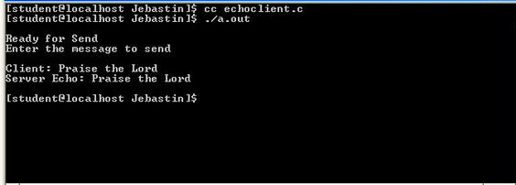

Server program:

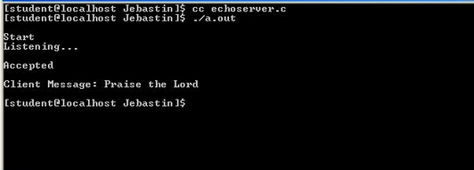

**RESULT:** Thus the program for TCP echo client server was executed and the output was verified.

**Conclusion:**

The Echo Protocol is a service in the Internet Protocol Suite defined in RFC 862. It was originally proposed for testing and measurement in IP networks. A host may connect to a server that supports the Echo Protocol using the Transmission Control Protocol (TCP) or the User Datagram Protocol (UDP) on the well-known port number 7. The server sends back an identical copy of the data it received.